**JAK of All Trades**

**Test-Driven Development**

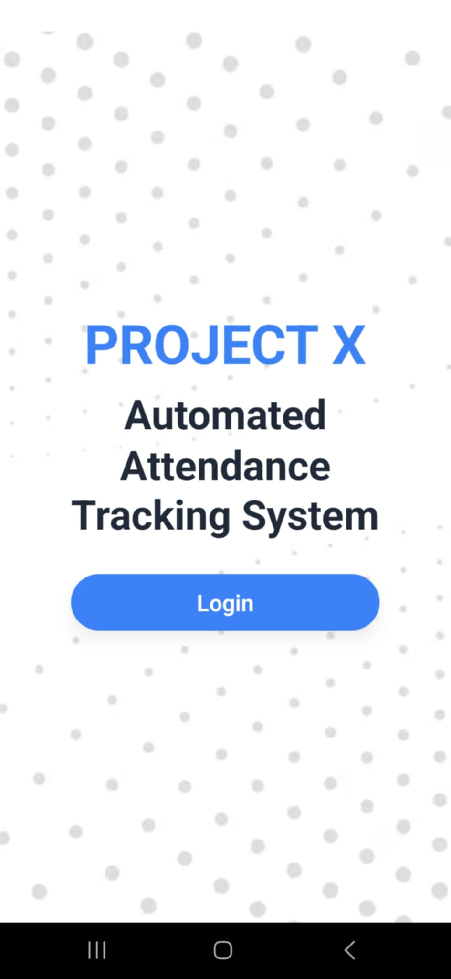

**This is the landing page of the system.**

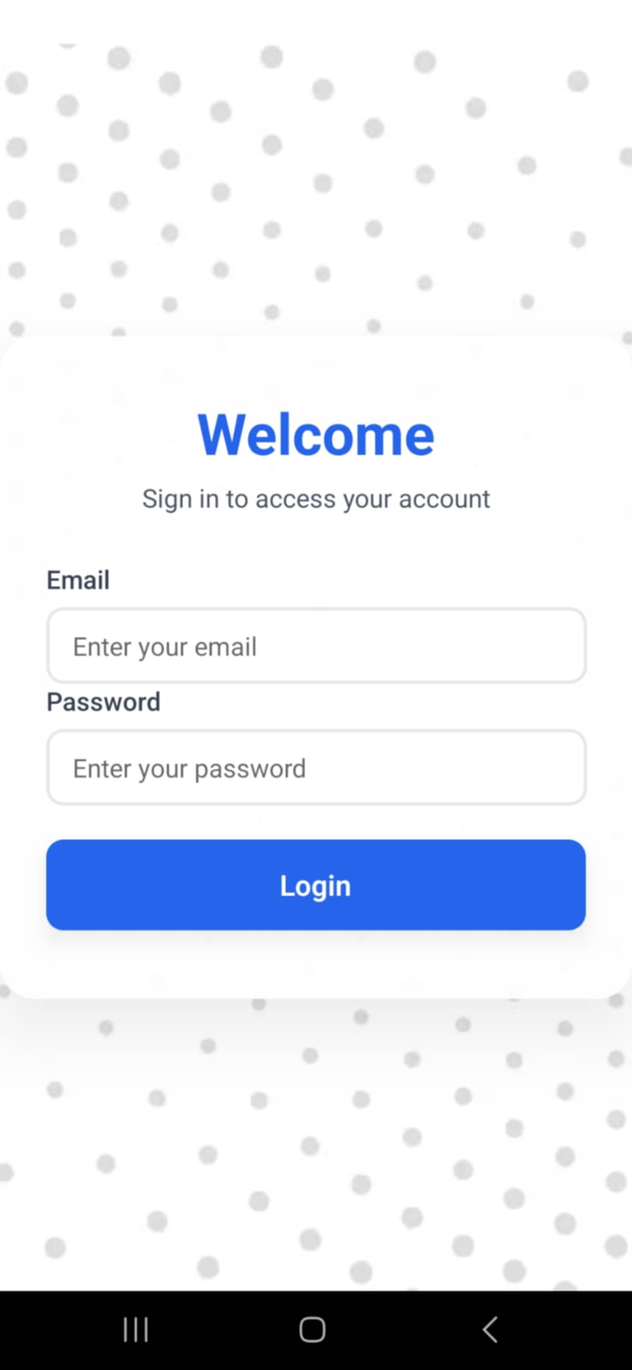

**A login screen interface prompting users to enter their email and password to access their account. It features a clean design with a blue "Login" button and a welcoming message at the top.**

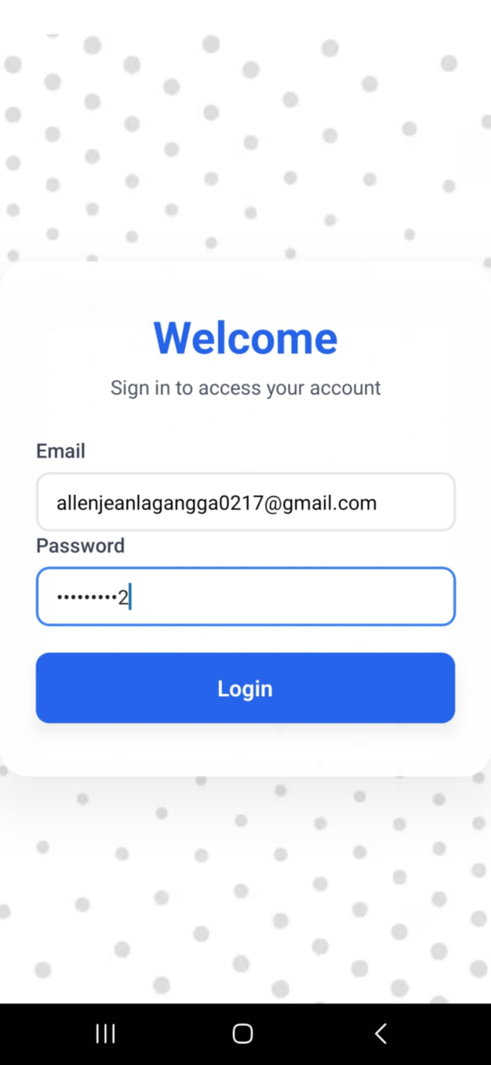

**This is a login screen for an app or website. It prompts the user to enter their email and password to access their account, with a blue "Login" button below the input fields.**

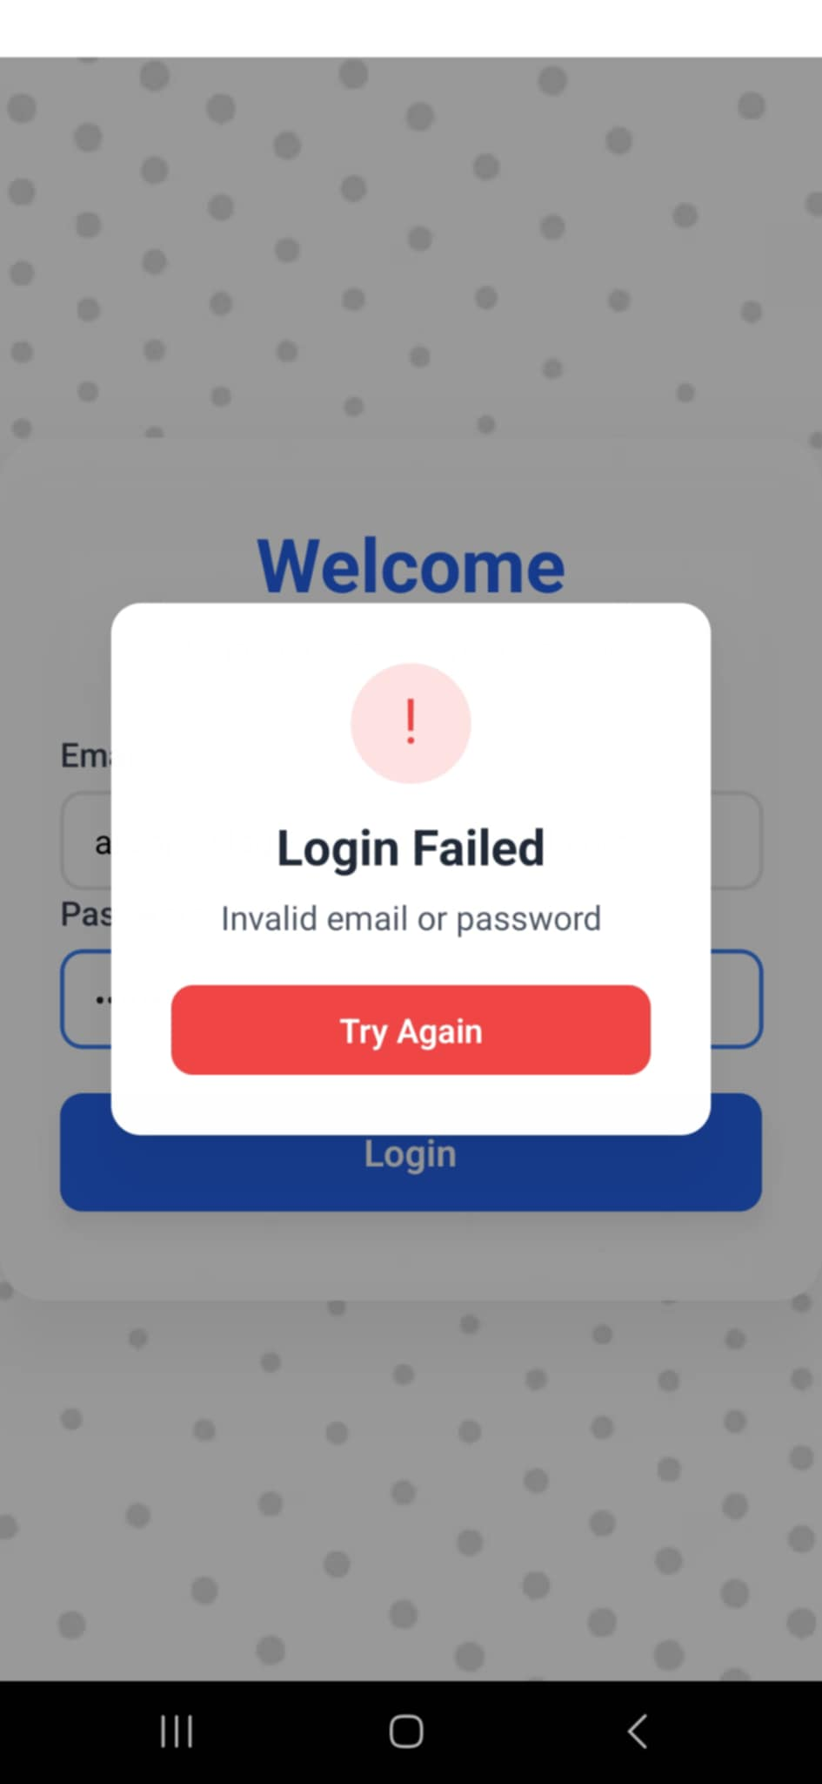

**A login error message appears, stating "Login Failed – Invalid email or password," with a "Try Again" button.**

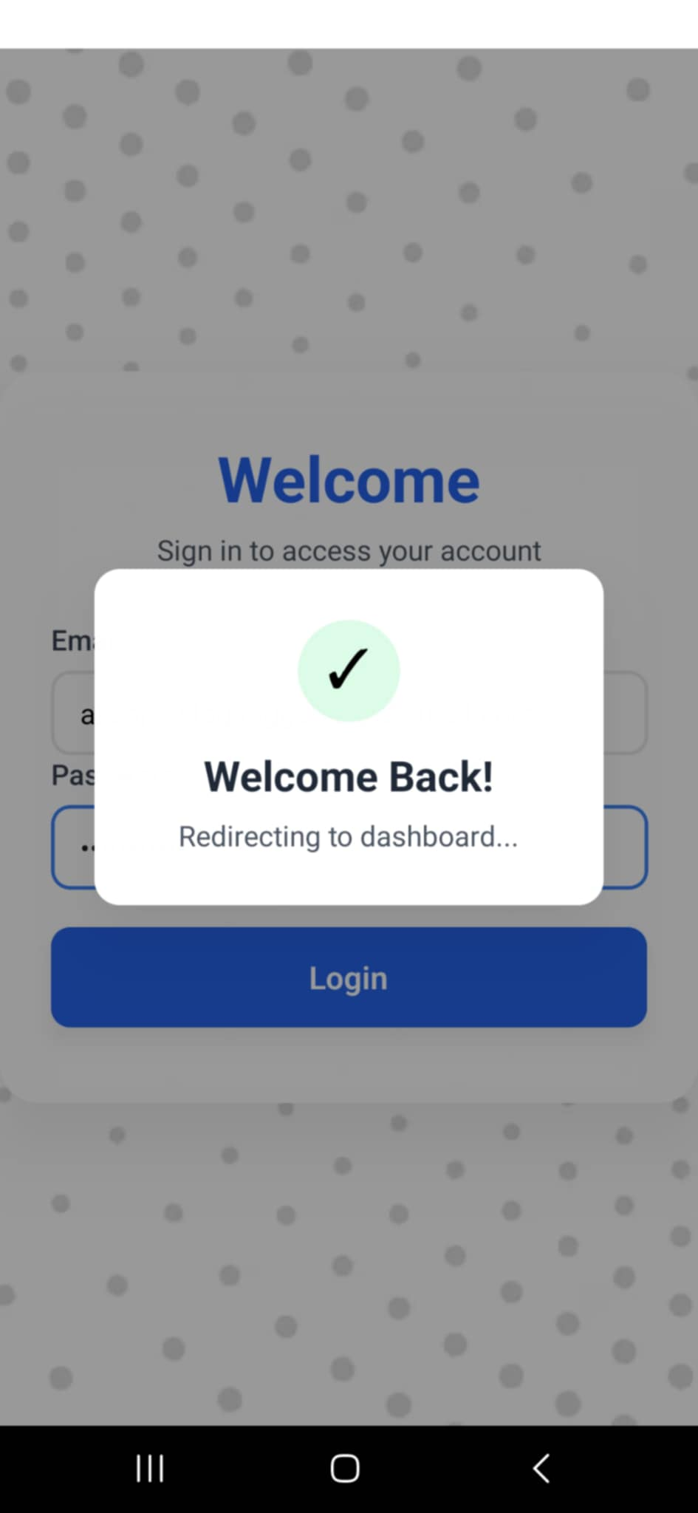

**This is a successful login confirmation popup saying "Welcome Back!" with a message that the user is being redirected to the dashboard.**

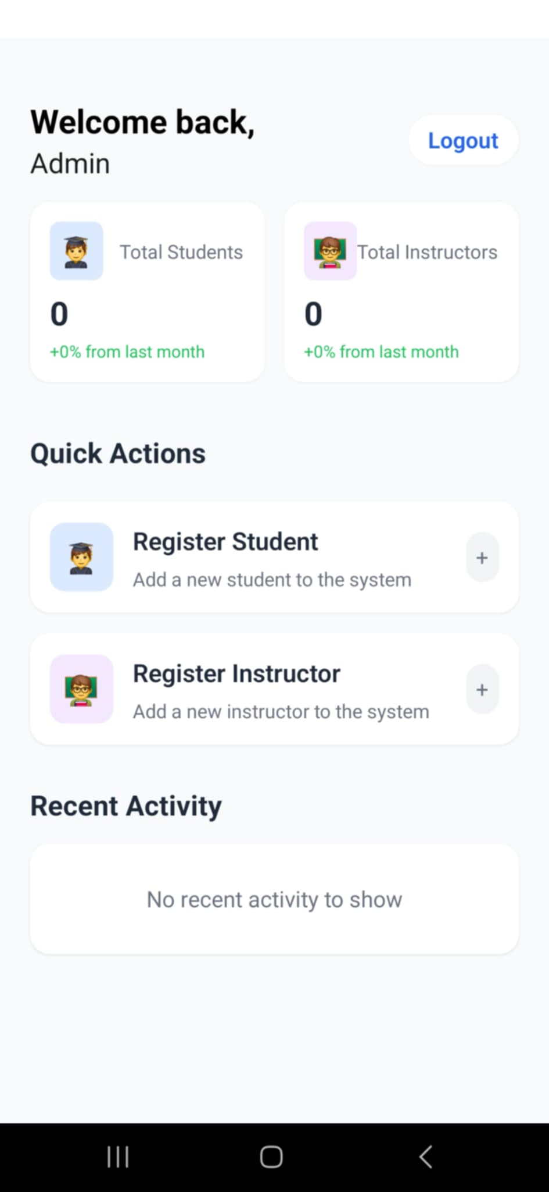

**Admin dashboard with welcome message, logout button, student and instructor counts (0), quick register options, and no recent activity.**

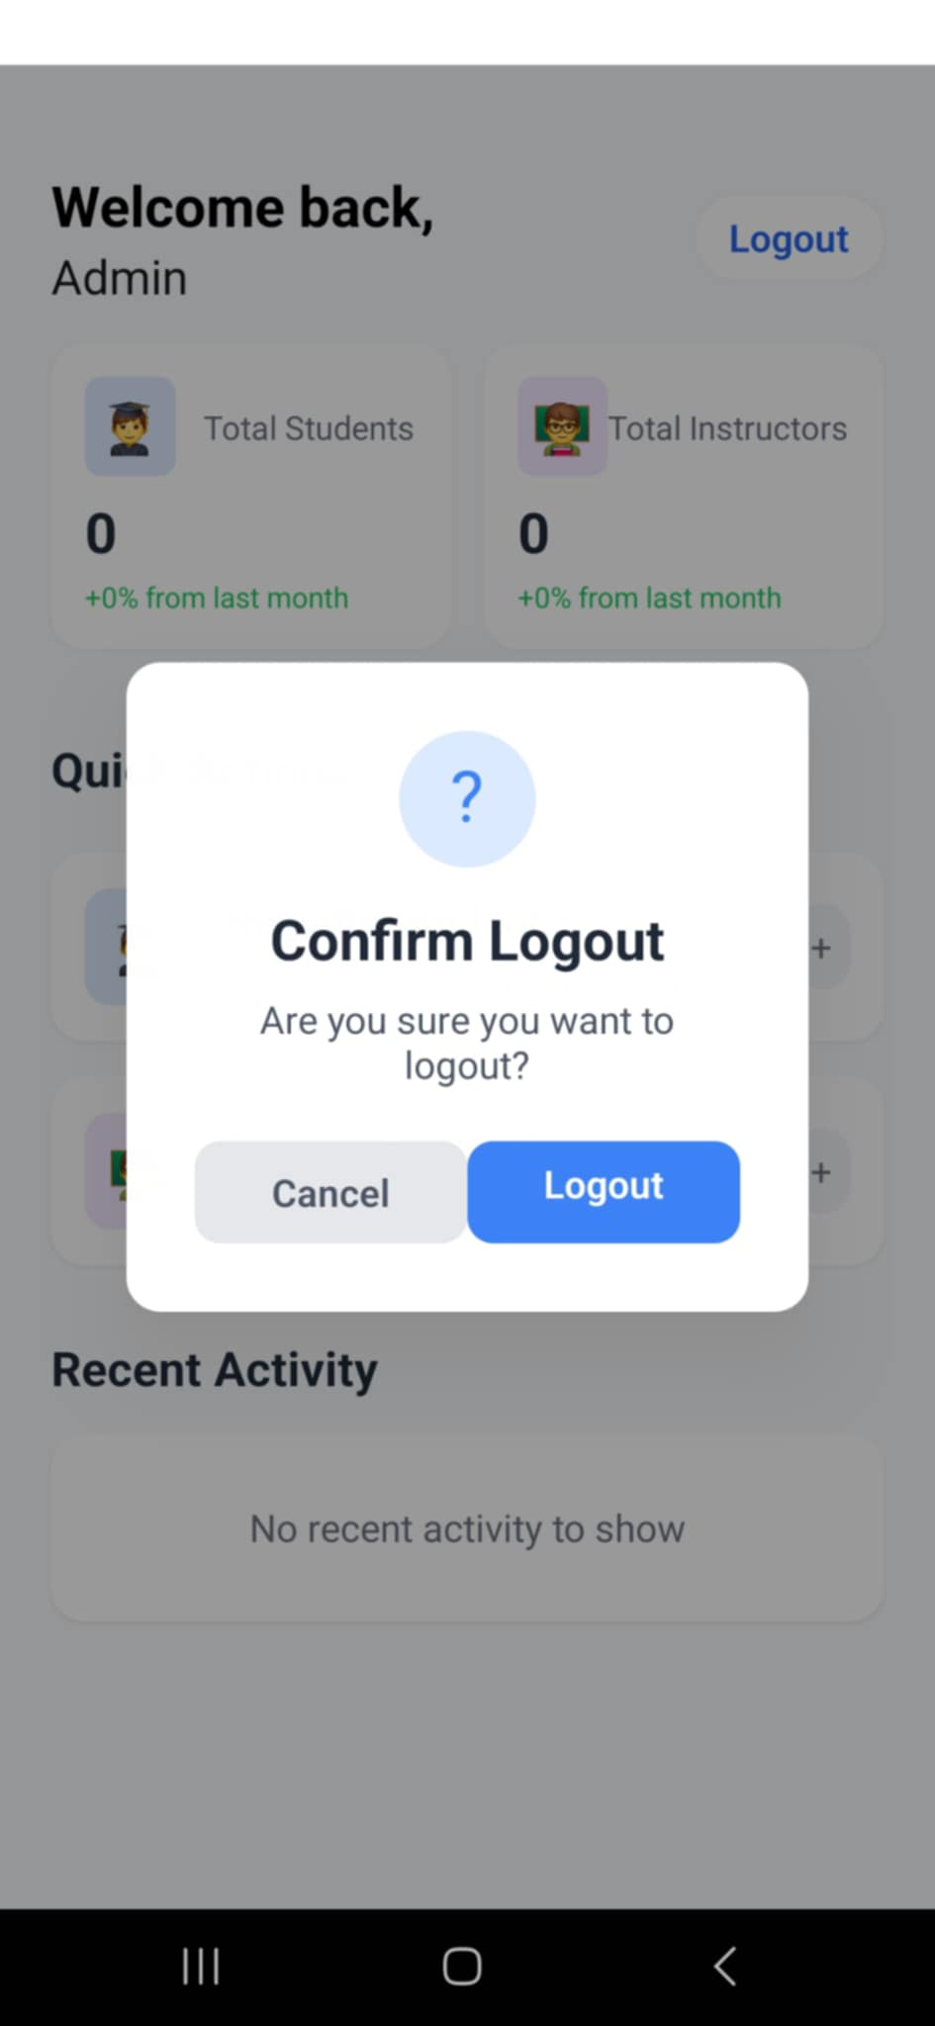

**A confirmation popup asks the user if they want to log out, with "Cancel" and "Logout" button options.**

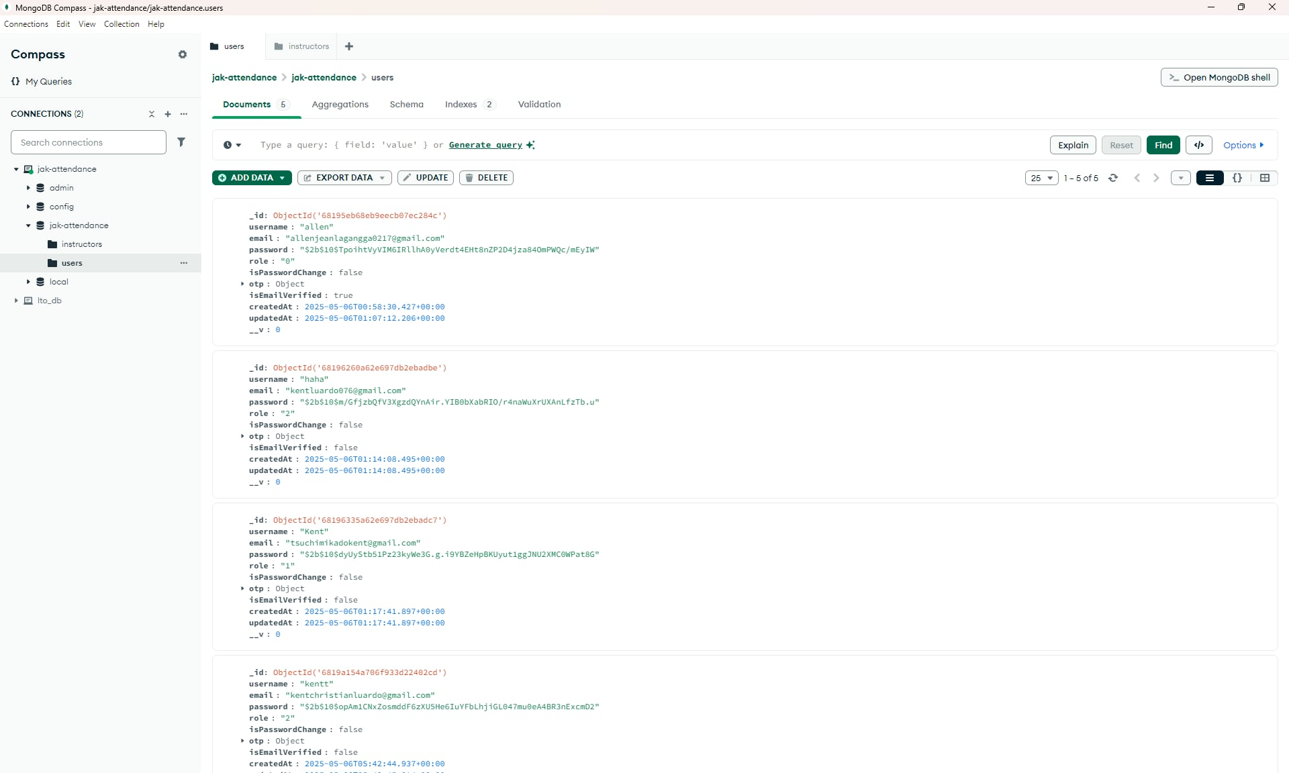

**This is a MongoDB Compass view showing user documents in the jak-attendance database. It lists user details such as email, password (hashed), role, and timestamps.**